Course Title: Building a Good Routine

Grade Level: 6th - 8th grade

Description:
This course will teach you how to build good routines for breakfast, lunch, dinner, and overall healthy nutrition habits. You will learn how to make balanced food choices and create long-lasting healthy food habits.
*ADD Standards*

Course Image:
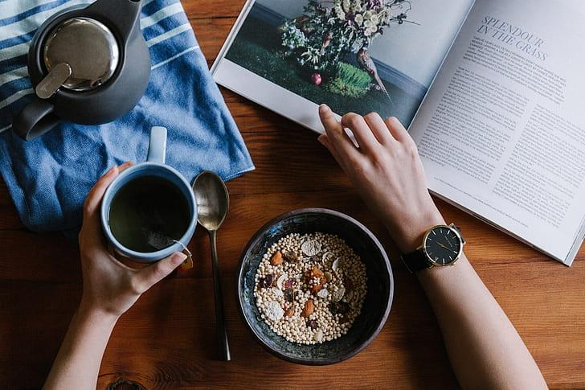
Video URL:
https://www.youtube.com/watch?v=Q4yUlJV31Rk

